11.3.4 Editors - Shader Editor - Sidebar - Options Tab
Options Tab - Settings panel 4
Settings panel with Eevee 4
Backface Culling 4
Blend Mode 4
Opaque 4
Alpha Clip 4
Alpha Hashed 4
Alpha Blend 4
Shadow Mode 4
None 4
Opaque 4
Alpha Clip 5
Alpha Hashed 5
Screen Space Refraction 5
Subsurface Translucency 5
Settings panel with Cycles 5
Pass Index 5
Surface sub panel 5
Multiple Importance 5
Transparent Shadows 5
Displacement 5
Volume Sub panel 5
Sampling 5
Interpolation 5
Homogeneous 5
Options Tab - Light panel 6
With Eevee 6
Type 6
Animate Property 6
Point light 6
Color 6
Animate Property 6
Power 6
Animate Property 6
Specular 6
Animate Property 6
Radius 6
Animate Property 6
Sun light 7
Color 7
Animate Property 7
Strength 7
Animate Property 7
Specular 7
Animate Property 7
Angle 7
Animate Property 7
Spot light 7
Color 7
Animate Property 7
Power 7
Animate Property 7
Specular 7
Animate Property 8
Radius 8
Animate Property 8
Area light 8
Color 8
Animate Property 8
Power 8
Animate Property 8
Specular 8
Animate Property 8
Shape 8
Animate Property 8
With Workbench 8
Type 8
With Cycles 9
Type 9
Point light 9
Color 9
Power 9
Size 9
Max Bounces 9
Cast Shadow 9
Multiple Importance 9
Sun light 9
Color 9
Strength 9
Angle 10
Max Bounces 10
Cast Shadow 10
Multiple Importance 10
Spot light 10
Color 10
Power 10
Size 10
Max Bounces 10
Cast Shadow 10
Multiple Importance 10
Area light 10
Color 10
Power 10
Shape 11
Max Bounces 11
Cast Shadow 11
Multiple Importance 11
Portal 11
Options Tab - Viewport Display panel 11
Color 11
Animate Property 11
Metallic 11
Animate Property 11
Roughness 11
Animate Property 12

Options Tab - Settings panel

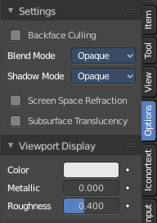
In the Options tab you will find general shading options for the current material for the render engines Eevee and Cycles. The Workbench renderer does not have any extra shading options.

The options tab moves around, dependent of what render engine you have chosen. With cycles the tab is at the end of the list.

The Settings panel appears with a mesh object selected.

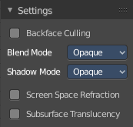
Settings panel with Eevee

Backface Culling
Hide the back sides of the geometry when rendering.

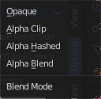
Blend Mode
The blend mode for transparent faces.

Opaque
Render the surface without transparency.

Alpha Clip
Use the alpha threshold to clip the visibility.

Alpha Hashed
Use noise to dither the binary visibility

Alpha Blend
Render polygon transparent, depending of the alpha channel of the texture.

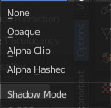
Shadow Mode
The shadow mapping method.

None
The material will cast no shadow.

Opaque
The material will cast shadow without transparency.

Alpha Clip
Use the alpha threshold to clip the visibility.

Alpha Hashed
Use noise to dither the binary visibility and use filtering to reduce the noise.

Screen Space Refraction
Use ray-traced screen space refraction's.

Subsurface Translucency
Add translucency effect to subsurface.

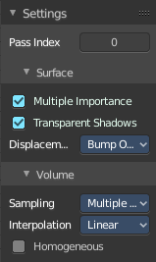
Settings panel with Cycles

Pass Index
Index number for the material render index pass

Surface sub panel

Multiple Importance
Use multiple Importance sampling for this material.

Transparent Shadows
Use transparent shadows for this material if it contains a Transparent BSDF

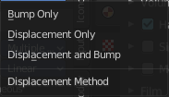
Displacement
Adjust the displacement method. Bump mapping is an old image based shader technique to fake displacement. Displacement deforms the geometry.

Volume Sub panel

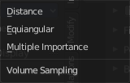
Sampling
The volume sampling method.

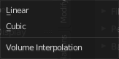
Interpolation
The volume interpolation method. Linear or cubic

Homogeneous
Use the same density for volume rendering.

Options Tab - Light panel

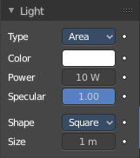
The Light panel appears with a light object selected.

With Eevee

Type
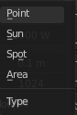
The light type. The light settings changes, dependent of what light type you have chosen.

Animate Property
This property can be animated.

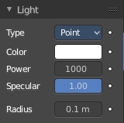
Point light

Color
The light color.

Animate Property
This property can be animated.

Power
The strength of the light in Watt.

Animate Property
This property can be animated.

Specular
Adjust the specular reflection multiplier.

Animate Property
This property can be animated.

Radius
The size of the point light.

Animate Property
This property can be animated.

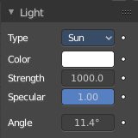
Sun light

Color
The light color.

Animate Property
This property can be animated.

Strength
The strength of the light. This value is not in Watt.

Animate Property
This property can be animated.

Specular
Adjust the specular reflection multiplier.

Animate Property
This property can be animated.

Angle
The angular diameter for the sun as seen from the earth.

Animate Property
This property can be animated.

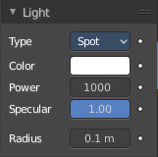
Spot light

Color
The light color.

Animate Property
This property can be animated.

Power
The strength of the light in Watt.

Animate Property
This property can be animated.

Specular
Adjust the specular reflection multiplier.

Animate Property
This property can be animated.

Radius
The size of the point light.

Animate Property
This property can be animated.

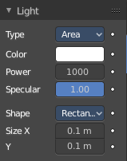
Area light

Color
The light color.

Animate Property
This property can be animated.

Power
The strength of the light in Watt.

Animate Property
This property can be animated.

Specular
Adjust the specular reflection multiplier.

Animate Property
This property can be animated.

Shape
The shape of the light emitting area of the light.
Size X / Y
The size of the light emitting area of the light.

Animate Property
This property can be animated.

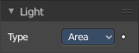
With Workbench

Type
The light type. The light settings changes, dependent of what light type you have chosen.

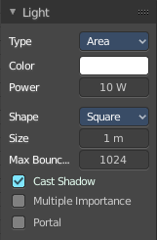
With Cycles

Type
The light type. The light settings changes, dependent of what light type you have chosen.

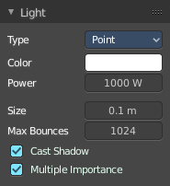
Point light

Color
The light color.

Power
The strength of the light in Watt.

Size
The size of the point light

Max Bounces
The maximum numbers of the bounces that this light will contribute to the render.

Cast Shadow
The light casts a shadow.

Multiple Importance
Use Multiple Importance sampling for this light.

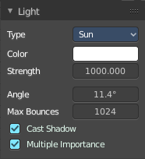
Sun light

Color
The light color.

Strength
The strength of the light. This value is not in Watt.

Angle
The angular diameter for the sun as seen from the earth

Max Bounces
The maximum numbers of the bounces that this light will contribute to the render.

Cast Shadow
The light casts a shadow.

Multiple Importance
Use Multiple Importance sampling for this light.

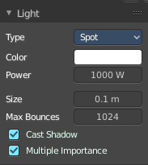
Spot light

Color
The light color.

Power
The strength of the light in Watt.

Size
The size of the point light

Max Bounces
The maximum numbers of the bounces that this light will contribute to the render.

Cast Shadow
The light casts a shadow.

Multiple Importance
Use Multiple Importance sampling for this light.

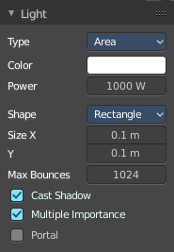
Area light

Color
The light color.

Power
The strength of the light in Watt.

Shape
The shape of the light emitting area of the light.
Size X / Y
The size of the light emitting area of the light.

Max Bounces
The maximum numbers of the bounces that this light will contribute to the render.

Cast Shadow
The light casts a shadow.

Multiple Importance
Use Multiple Importance sampling for this light.

Portal
Use this light to guide sampling of the background. This will make the light invisible.

Options Tab - Viewport Display panel

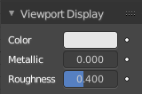
Adjust how the mesh object is displayed in the viewport when the viewport shading in the 3D view is in solid mode.

The content is the same for all three render engines.

Color
The color.

Animate Property
This property can be animated.

Metallic
Metallic look.

Animate Property
This property can be animated.

Roughness
The roughness.

Animate Property
This property can be animated.

